**Project C: Tree, Alien Fish, Flower and Rotating Sphere**

***CompSci 351-1: Intro to Computer Graphics* *Fall 2021***

Student Name: Jiaqi Guo NetID: JGR9647

* **Project Description**

1. 图片包含 游戏机, 桌子, 笔记本, 电脑

   描述已自动生成***Project Goal:*** In this project we are going to create good interactive lighting and materials in WebGL in a visually interesting animated interactive ‘virtual world’. Which means we will no longer implement cartoonish fixed colors at each vertex, but instead, compute colors in our vertex and fragment shader programs by simulating how a light source illuminates a surface whose material reflects some fraction of that light towards the camera.

**Figure 1 Overall Shortcut of Project C**

In addition to the specifications already mentioned in the previous project, each of our 3D parts will include a surface-normal attribute for each vertex, and also a material descriptor that chooses a set of RGB reflectance values. Besides, we will use several vertex/fragment shader pairs to compute the Phong and Blinn-Phong lighting model with both ‘Gouraud’ shading and ‘Phong’ shading.

1. ***Project Detail:*** Our 3D world consists of 3 kinds of 3D rigid assemblies (figure 1), which are the *tree* , the *alien fish*, the *flower,* and a *slow-spinning sphere* at the central of the world.

All 3D assemblies can move continually without requiring any user instruction. As illustrated in the figure above, each of them is assigned with an obviously different-looking Phong material (with adjustable parameter). In addition, there is a light source in the world that can be moved around, which can illuminate these assemblies using the Phong lighting model. Apart from that, there are four shading methods for the user to choose.

* **A Quick User Guide**
* ***FUNCTION 1: Four Selectable Shading Methods***

1. ***What is it? :*** Users can switch between Phong Shading and Gouraud Shading, as well as between Phong lighting and Blinn-Phong lighting, 4 different methods.
2. ***How to control? :*** Pressing the *“Switch Gouraud/Phong Shading”* to select *shading methods*. Pressing *“Switch Blinn-Phong Lighting”* to select the *lighting methods*. Pressing *“Hide Ground Grid”* tohide *the background grid*.

* ***FUNCTION 2: Choosing Material for 3D Assemblies***

1. ***What is it? :*** Users can select their favorite material for these four 3D objects from the drop-down bar or drag the slider to adjust the "brightness (Shininess)" of the material.
2. ***How to control? :*** For each assembly, Choose one of 22 materials from the drop-down bar. Then drag the slider to select the “shininess” of the material as required.

* ***FUNCTION 3: Assigning Adjustable Phong Materials to Rigid Parts Shown On-Screen***

1. ***What is it? :*** Users can change three parameters to make each 3D rigid parts distinctive.
2. ***How to control? :*** Enter 'R' (red), 'G' (green), 'B' (blue) values to modify the Ambient, Diffuse, and Specular light three parameters.
3. ***Attention:*** Pressing “Reset” to reset all changes to the initial state.

* ***FUNCTION 4: Controlling the Position of the Non-directional Lighting Source***

1. ***What is it? :*** Users can enter three number to control the position of the lighting source.
2. ***How to control? :*** Enter three floating point numbers corresponding to x, y, and z coordinates.
3. ***Attention:*** Pressing “Reset” to reset all changes to the initial state.

* ***FUNCTION 5: User-Controllable Camera Position & Viewing Direction***

1. ***What is it? :*** This function enables the user to control the position and the aiming direction of the perspective camera with simply pressing the arrow keys (or mouse dragging) and “AWSD” keys on the keyboard.

***Camera position*** *—— using arrow keys or mouse dragging*

***Aiming angle*** *—— using “AWSD” keys*

1. ***How to control? :*** Pressing the corresponding keys and dragging your mouse on your screen.
2. ***Attention:*** Pressing key “R” to reset the camera.

* **Result Explanation**

1. ***Example: Light Source and 3D Assemblies***

The position of the light source is initialized at coordinates (7.0, 6.0 ,5.0).is to allow the user to better observe the lighting characteristics of different materials. Each 3D assembly is initialized with a different material along with different shininess (e.g. Sphere material: red plastic), which the user can modify as needed.

**Figure 2 All of our 3D Assemblies**

1. ***Example: Four Different Shadings Method***

In this example, we will use spheres as an example to show four

different shading methods that can be chosen, which are:

1. Blinn-Phong lighting with Phong Shading
2. Blinn-Phong lighting with Gouraud Shading
3. Phong lighting with Gouraud Shading
4. Phong lighting with Phong Shading

They correspond to the following four pictures from left to right. Among them, ‘Gouraud’ shading produces a faceted appearance, while ‘Phong’ shading will have smooth, facet-free surface with nice rounded specular highlights.



**Figure 3 Four Different Shading Methods (From left to right correspond to the a, b, c, d mentioned above)**

1. ***Example: Select Material for each 3D Assemblies***

Compared to Figure 2, we modified the materials (figure 4) for each 3D Assemblies. For example, the material of the sphere changed from “*Red plastic”* to “*Emerald”*.

**Figure 4 Change the Materials**

After modifying the material, the shininess of each 3D assembly will change due to the parameters of the material.

1. ***Example: Change the Position of Lighting Source***

In this program (assuming we use the default camera position), the user can control the position of the light source by manually entering a set of coordinates. For example, in figure 5 (left) our light source is set at ***Light source 1*** (x=10.0, y=0.0, z=0.0), so the virtual light will illuminate all objects at the front side. In Figure 5 (right), we set the light source at ***Light source 2*** (x=0.0, y=10.0, z= 0.0), and we can see that the object will be illuminated from the right side.

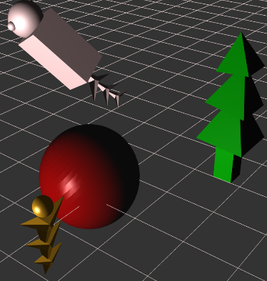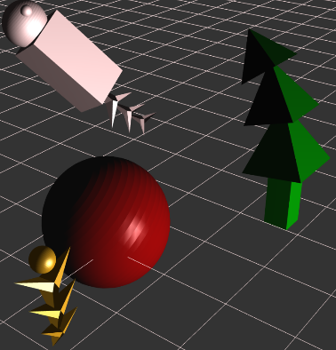

**Figure 5 Left: lighting source 1 Right: Lighting source 2**

* 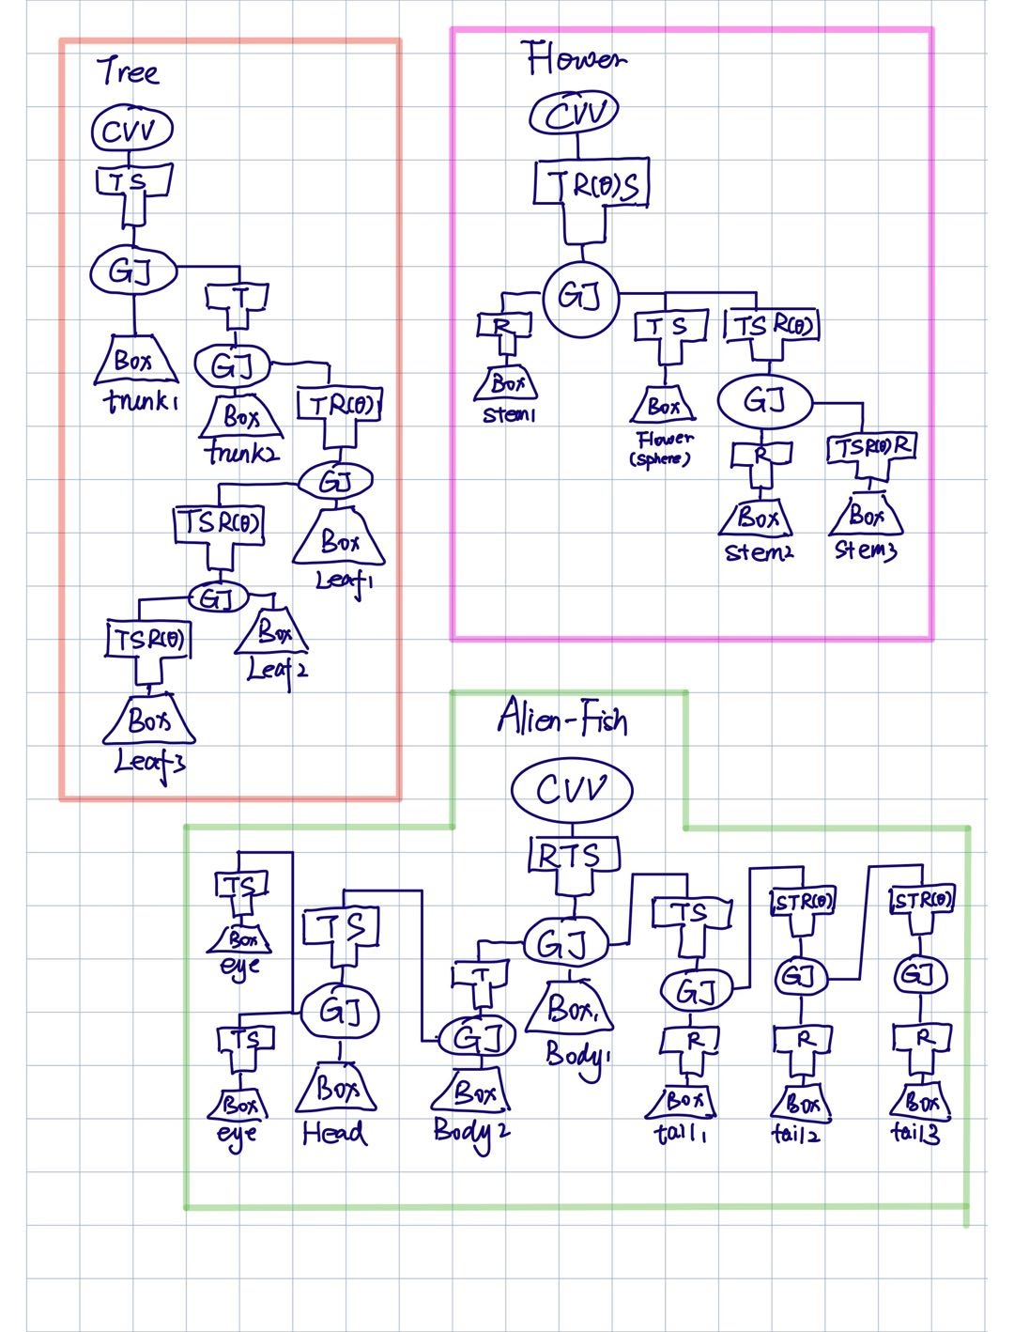**Scene Graph**